10 .(a) Develop an applet that displays a simple message.

PROGRAM:
import java.awt.*;
import java.applet.*;
/*<applet code="FirstApplet" width=400 height=300></applet>*/
public class FirstApplet extends Applet
{
public void paint(Graphics g)
{
g.setColor(Color.blue);
Font font=new Font("Arial", Font.BOLD, 16);
g.setFont(font);
g.drawString("This is My First Applet",60,110);
}
}

OUTPUT:

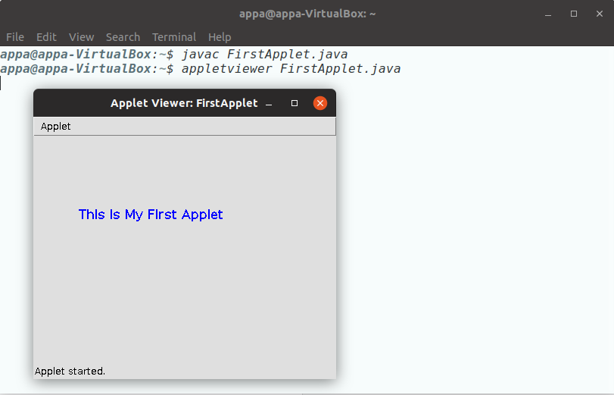

b. Design a Java program compute factorial value using Applet.

PROGRAM:
import java.awt.*;
import java.lang.String;
import java.awt.event.*;
import java.applet.Applet;
/*<applet code="FactorialApplet" width=550 height=250>
</applet>*/
public class FactorialApplet extends Applet implements ActionListener {
Label L1,L2;
TextField T1,T2;
Button B1,B2;
public void init() {
L1=new Label("Enter any integer number : ");
add(L1);
T1=new TextField(10);
add(T1);
L2=new Label("Factorial of Number : ");
add(L2);
T2=new TextField(10);
add(T2);
B1=new Button("Compute");
add(B1);
B1.addActionListener(this);
B2=new Button("Clear");
add(B2);
B2.addActionListener(this);
}
public void actionPerformed(ActionEvent e) {
if(e.getSource()==B1)
{
int value=Integer.parseInt(T1.getText());
int fact=factorial(value);
T2.setText(String.valueOf(fact));
}
else if (e.getSource()==B2) {
T1.setText("");
T2.setText("");
}
}
int factorial(int n) {
if(n==0)
return 1;
else
return n*factorial(n-1);
}
}

OUTPUT:

